Project report

**IBM**

**Nutrition Assistant**

[Modern Web Application]

Project by

PREETHIMAHALAKSHMI.M

NINITHA.S

MATHUMITHA.S

PRIYADHARSHINI.M

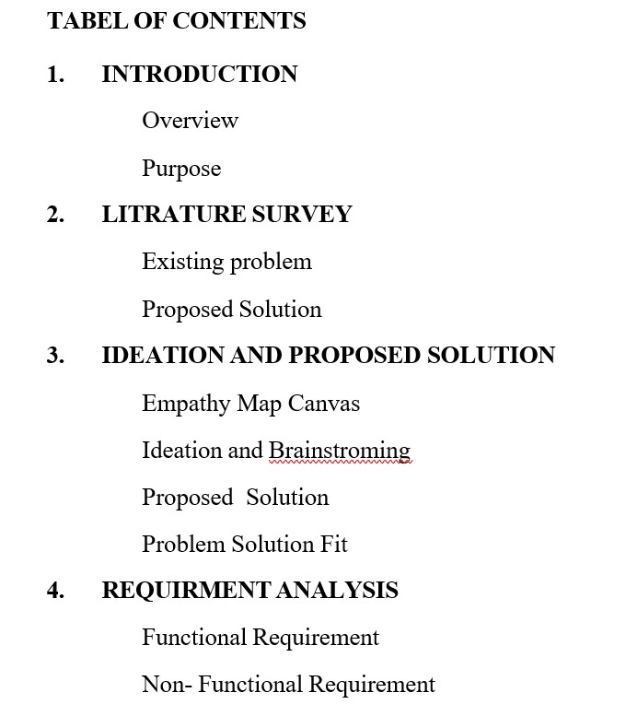

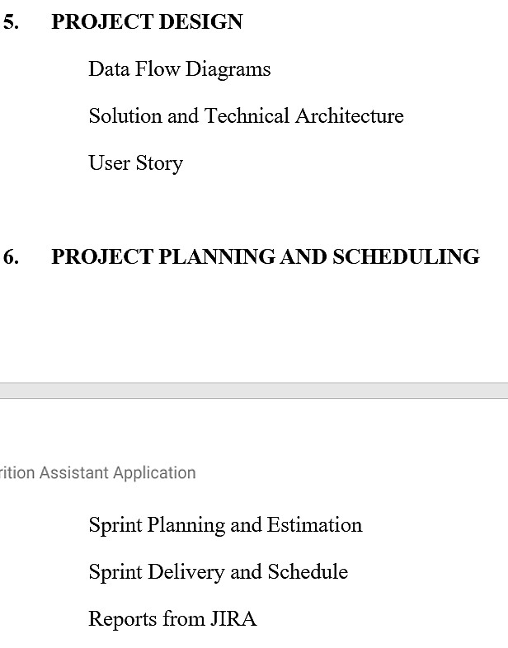

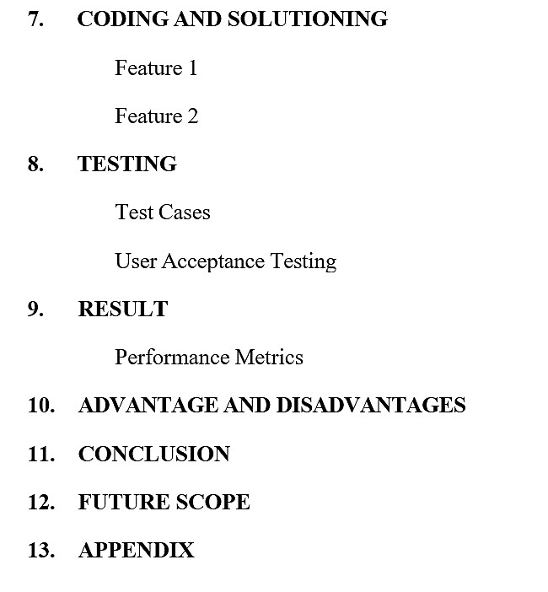

# 1.Introduction

## 1.1 Overview

As there is improvement in people’s standards of living, obesity rates are increasing at an alarming speed, and this is reflective of the risks to people’s health.People need to control their daily calorie intake by eating healthier foods. However, most of food packaging comes with nutrition labels, it’s still not very convenient for people to refer.

Most people understand the repercussions of eating fast food but sometimes the repercussions are unexpected and may require the services of a personalinjury lawyer. Most of my favorite foods cause weight gain and if eaten consistently, could lead to diabetes. In the last several years, there have been a handful of displeased fast-food eaters who took legal action against the fast-food chains to either make an easy buck or hold them accountable for their lousy products.

### 1.2 Purpose

The main purpose of this Web application is to help people know the nutrient value of the food they eat. This web app provides a service where the user can feed the food image/ food name/image URL and the app provides the nutrient value of the food. The user can also feed the daily consumption of food with time and date.Then he can access the food details whenever required.The nutrient detailsare also sent to the user mail.

This application can be used personally to take of ones health,recommended by hospitalsor the doctors to track the user daily food consumption, We will know more about this further.

# 2.LITRATURE SURVEY 2.1Existing problem

In this busy world people can't track the food they consume and it is difficult to find the nutrients of all the food they consume. Over consumption or under nutrition can lead to serious health issues. These may be calcium/ iron/vitamin deficiencies or the over consumption of carbohydrates and sugar that causes obesity and diabetes. Which may further lead to serious health issues. There is urgent action required to maintain a balanced diet in order to have a good immunity.

## 2.2 Proposed solution

Our web app used the food image given by the user then processes that to the nutrient values of the food then displays to the user.these can reduce the user's effort to enter the food details.he can simply capture the food image and enter into the web app.

The user can enter the food details that he consumes daily on the basis of time and date of consumption. we then add the food details into the user table. the user can then go to the diary page and view the data entered by him between any particular dates. He can also view the aggregate nutrient details. We have providedan email servicewhere users will get the aggregate nutrientdetails.

This application can be used on the recommendation of the doctor or the hospitals where one can track all the data that the patient consumed to track the nutrientdetails of the patient.

# 2.3 Problem Statement

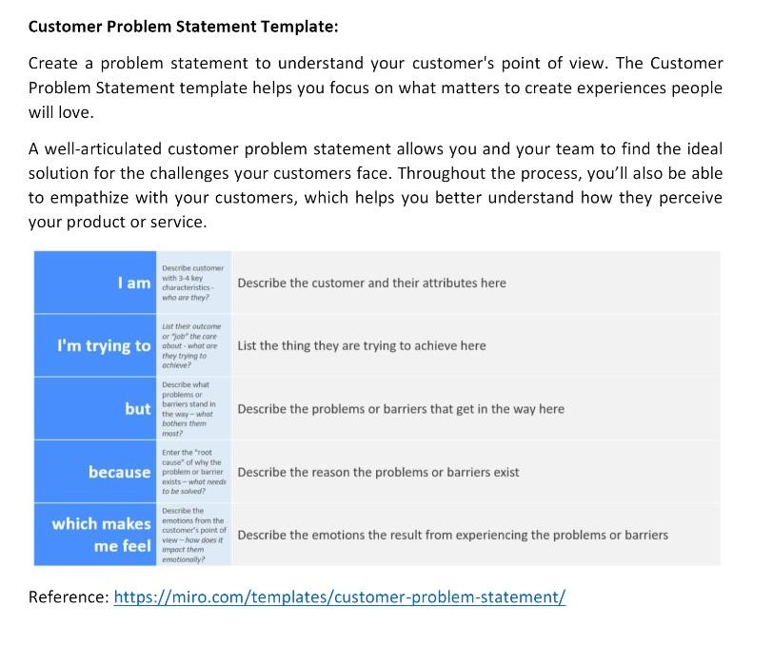

# 3.IDEATION & PROPOSED SOLUTION 3.1Empathy Map Canvas

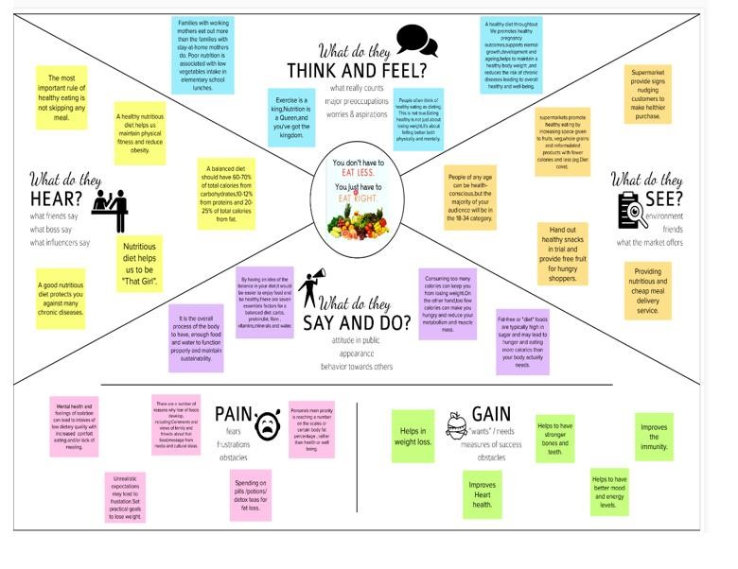

## 3.2 Ideation And Brain Storming

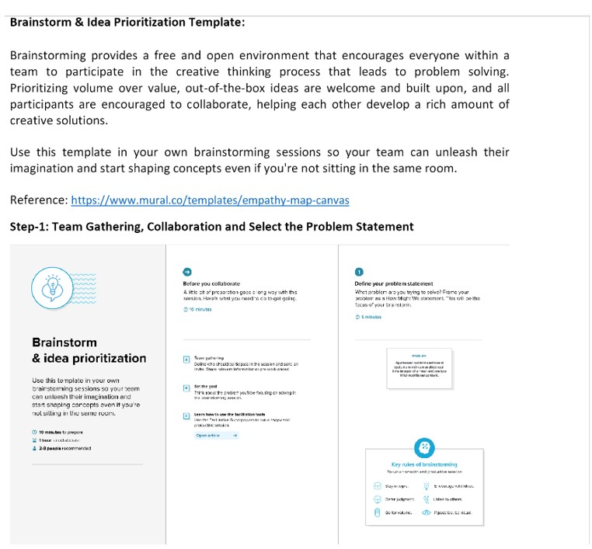

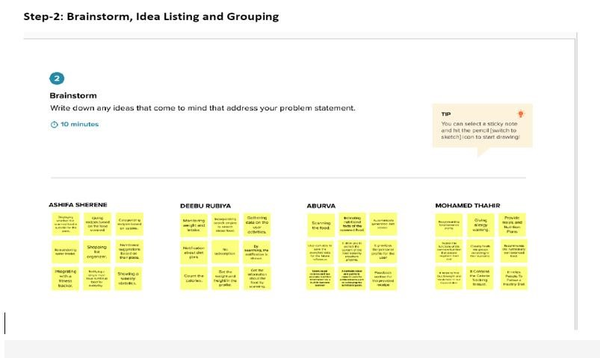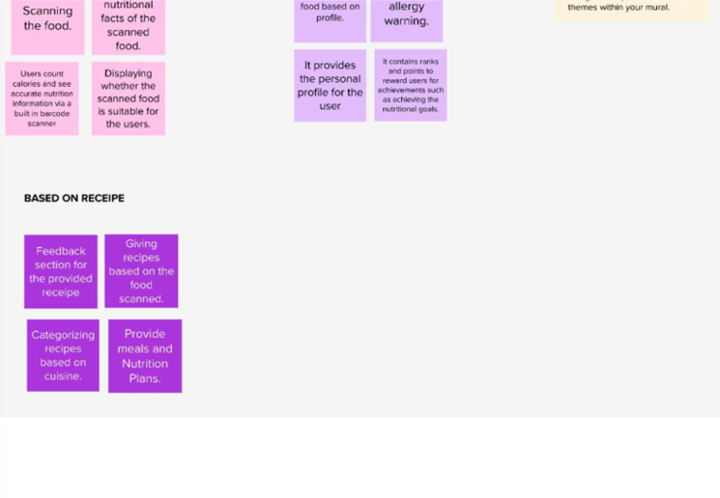

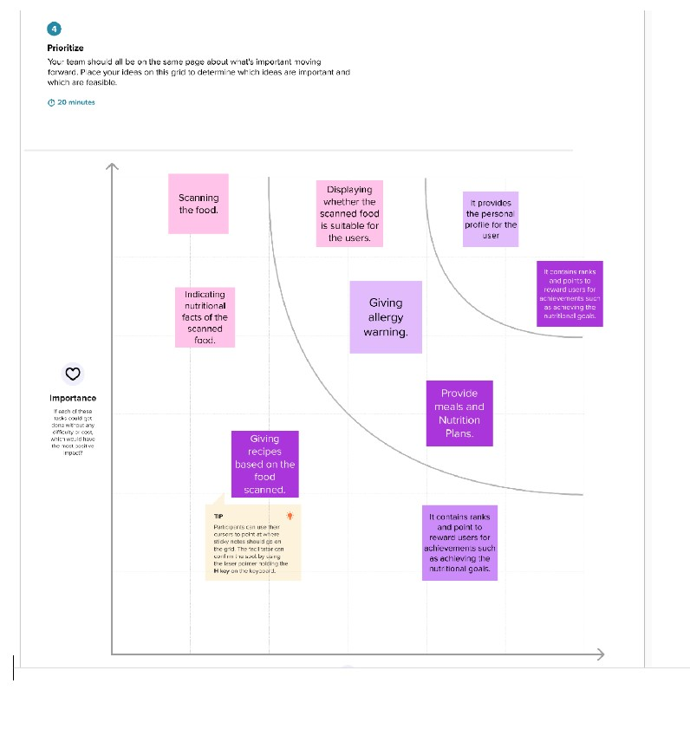

**3.3 Proposed Solution:**

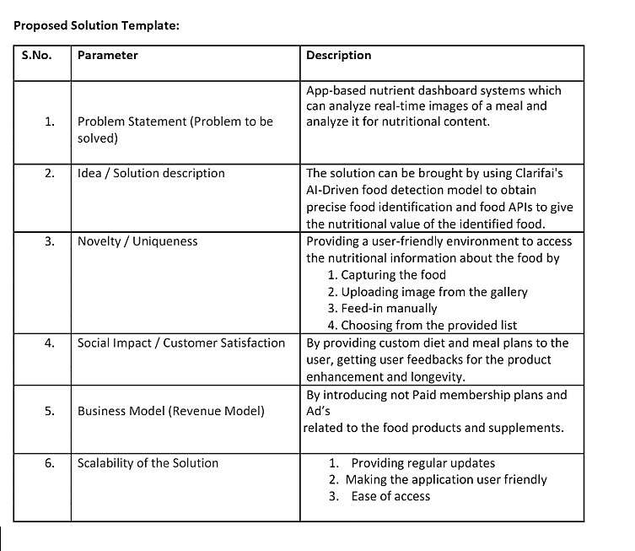

## 3.4 Problem Solution

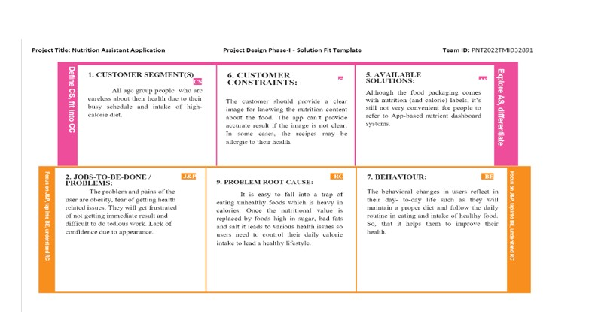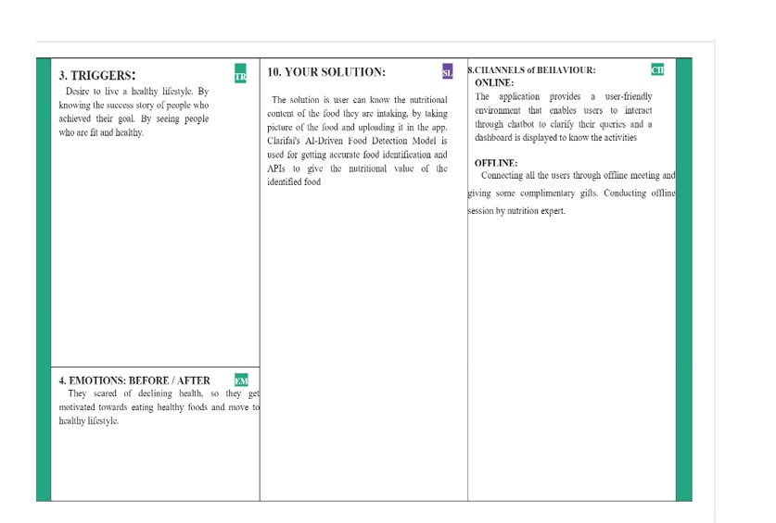

# 4.REQUIREMENT ANALYSIS

## 4.1 Functional requirement

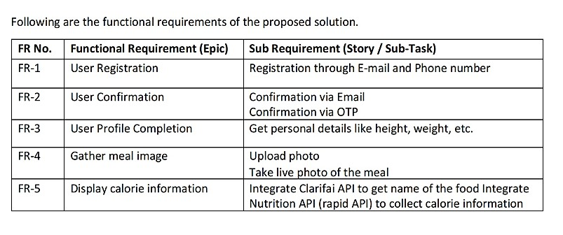

## 4.2 Non-Functional requirement

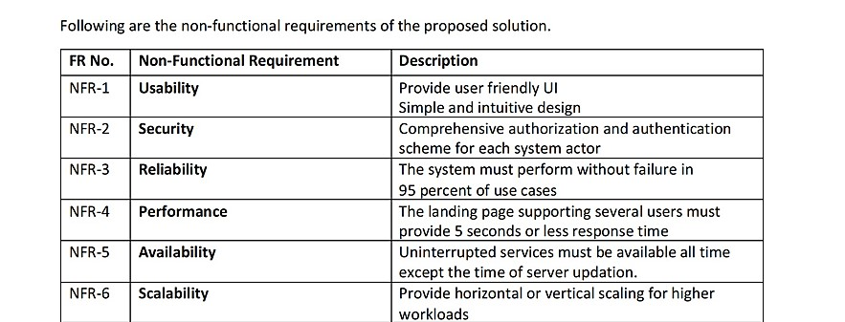

# 5 PROJECT DESIGN

## 5.1 Data Flow Diagrams

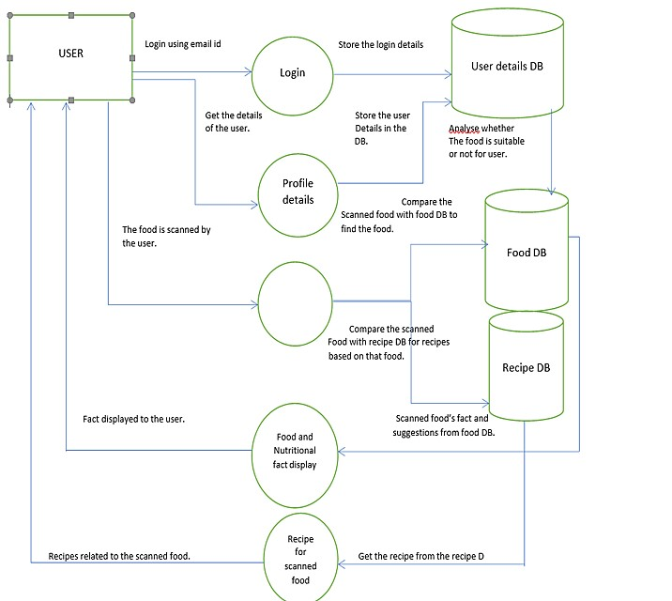

## 5.2 Solution &Technical Architecture

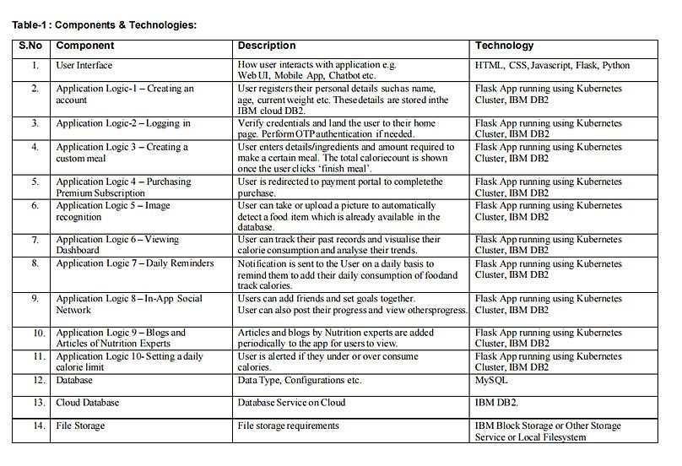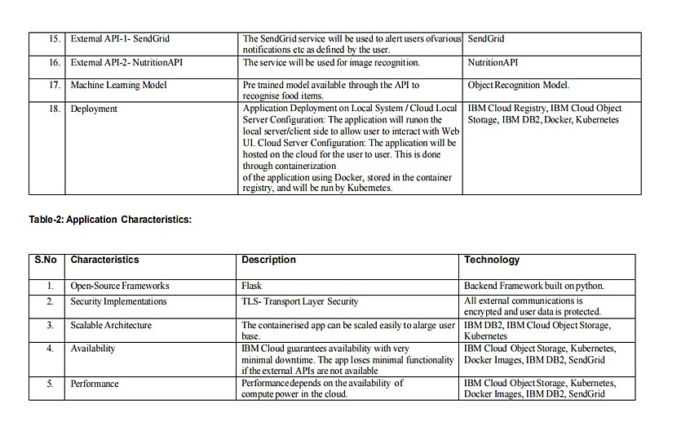

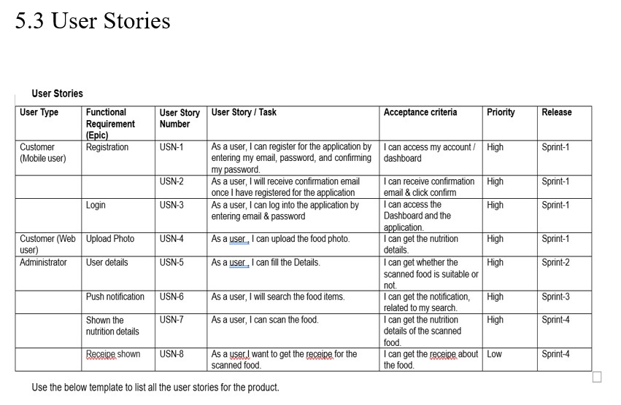

# 6.PROJECT PLANNING & SCHEDULING

## 6.1 Sprint Planning & Estimation

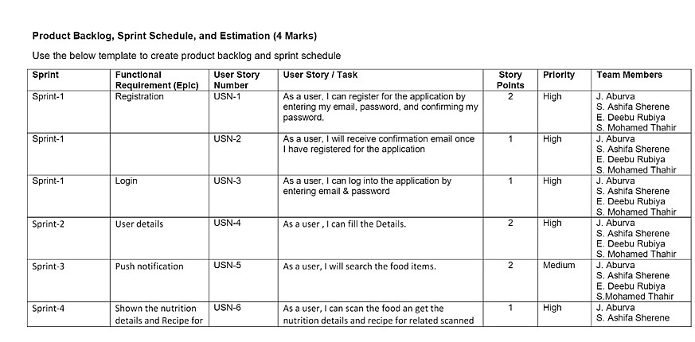

## 6.2 Sprint Delivery Schedule

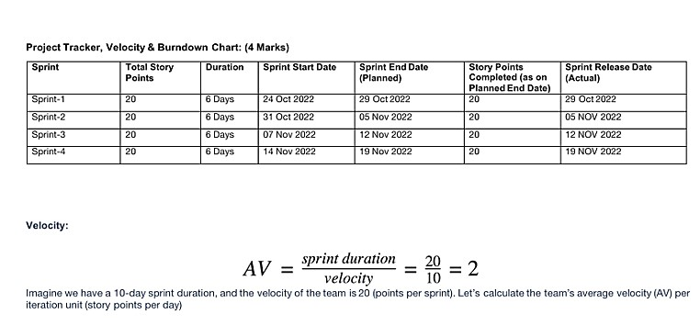

# 7 CODING & SOLUTIONING

**LOGIN**

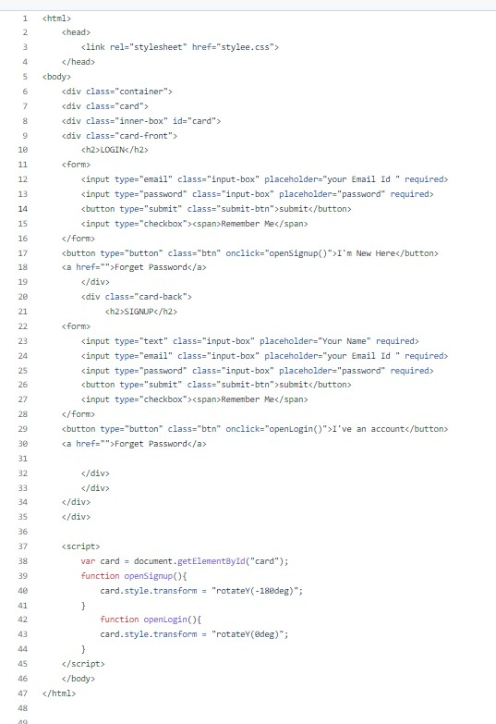

## STYLE.CSS

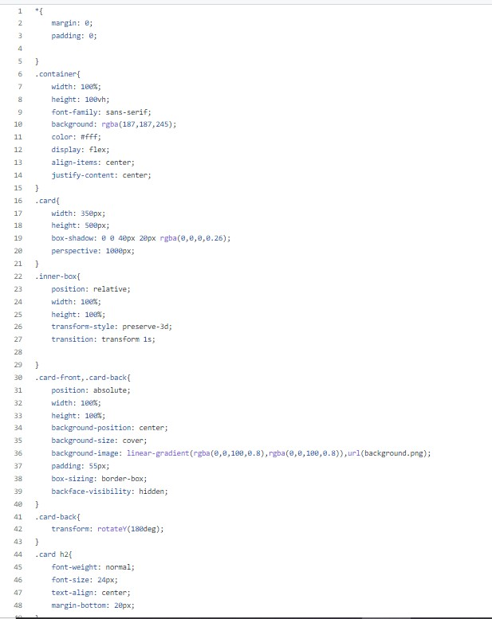

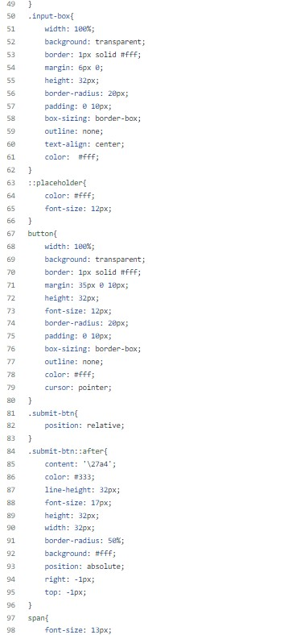

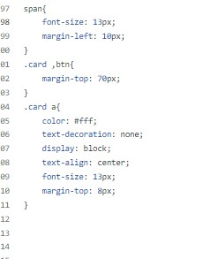

**HOME.HTML**

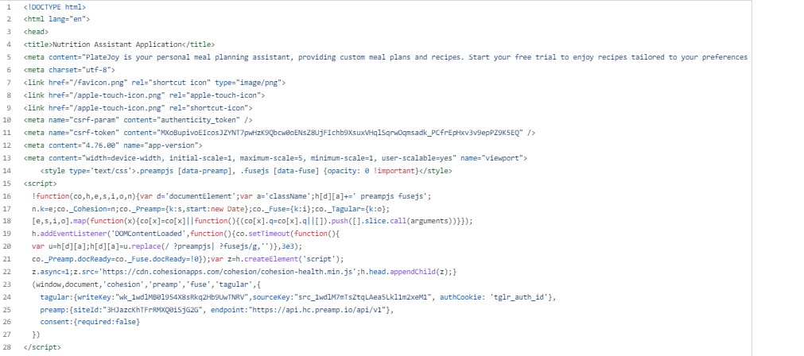

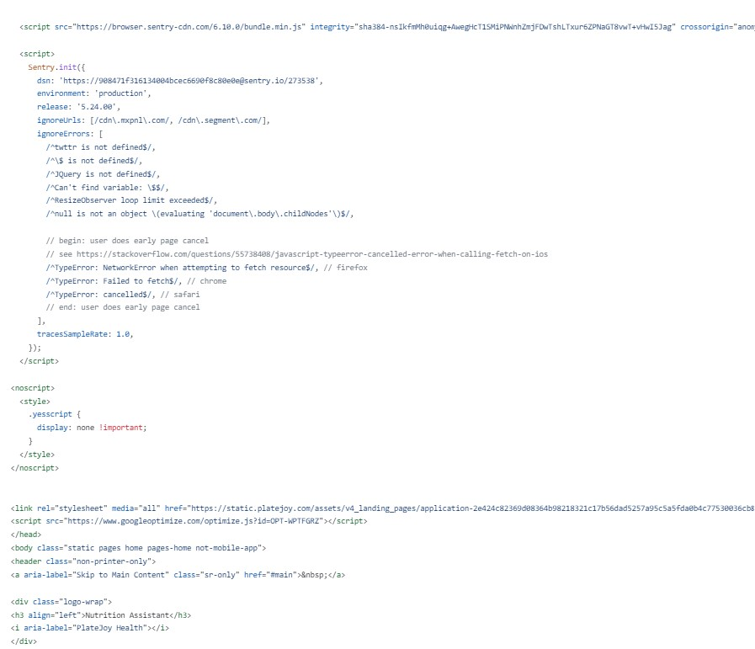

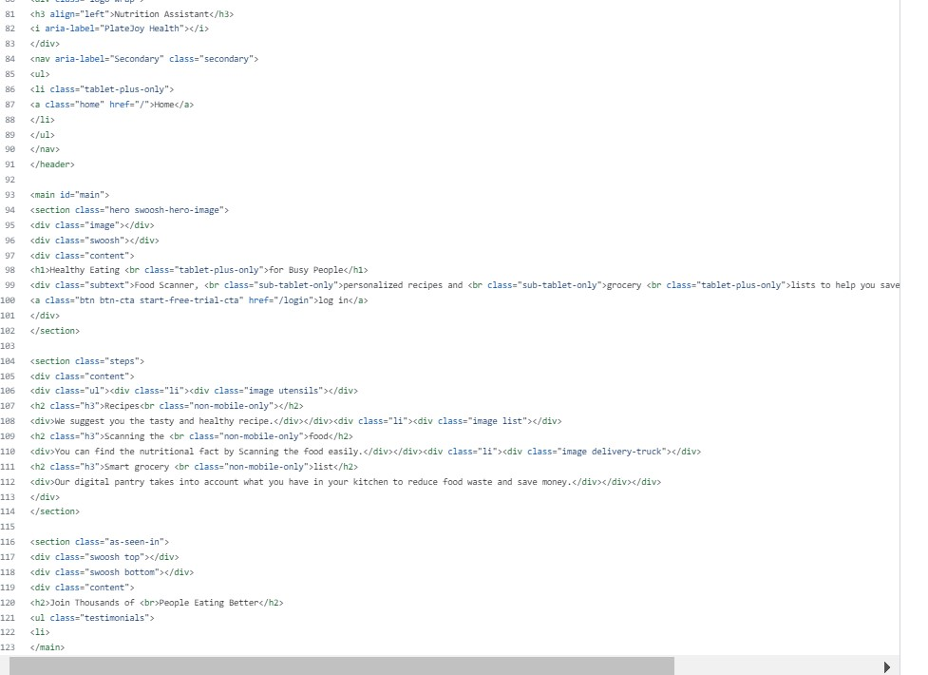

**UPLOAD PAGE:**

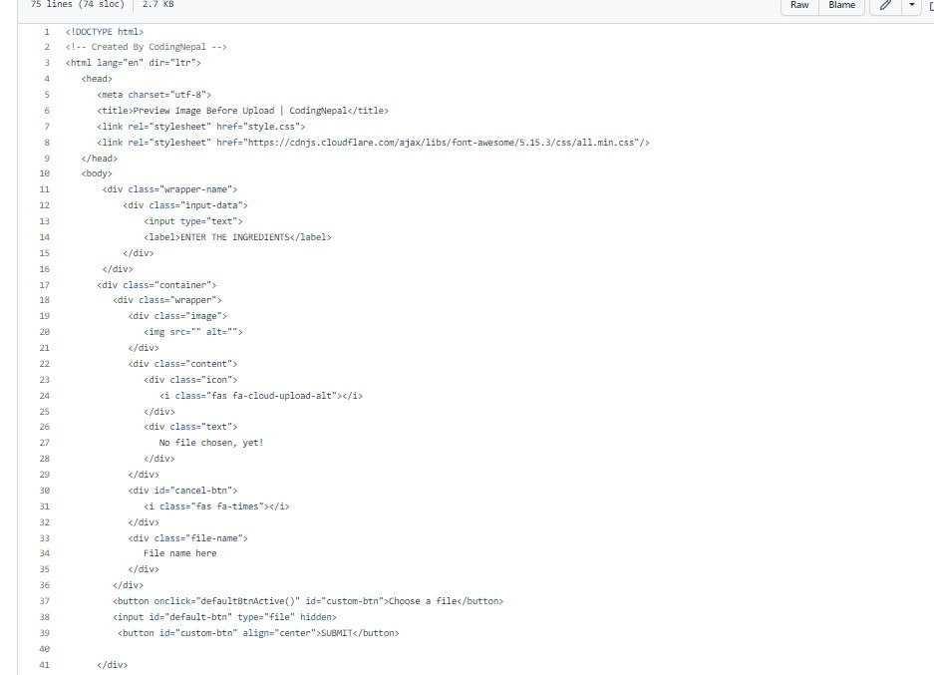

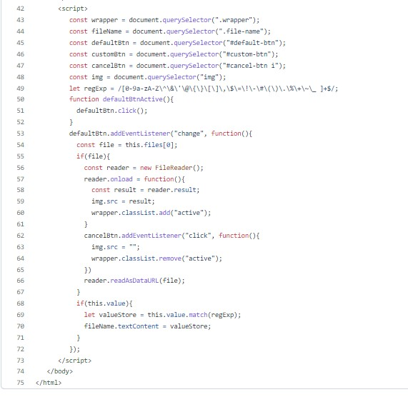

**REGISTRATION :**

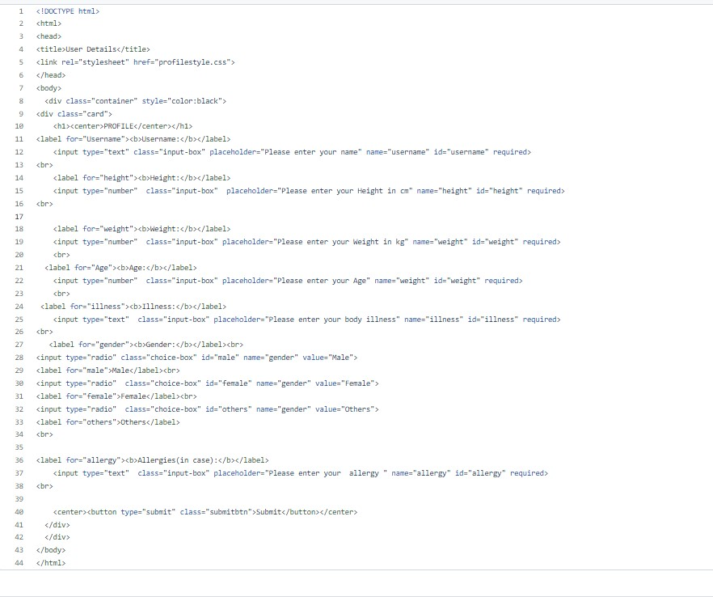

**9**.**TESTING**

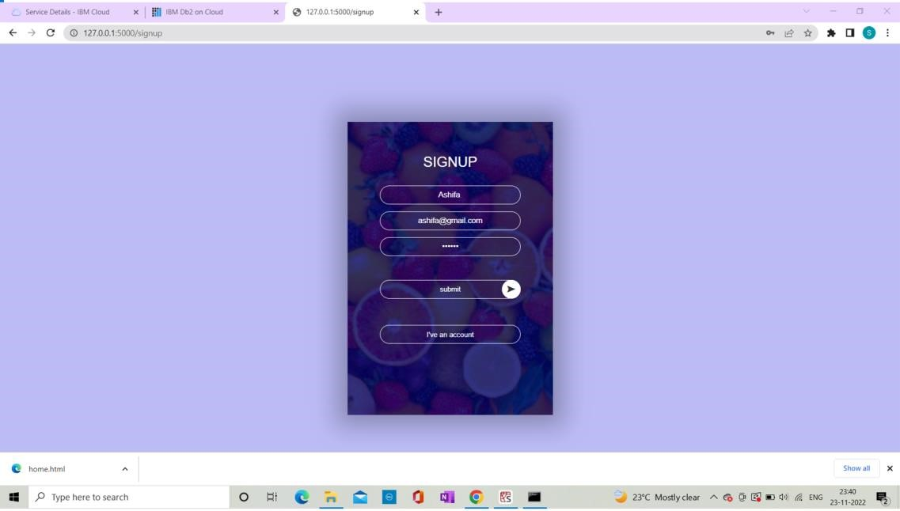

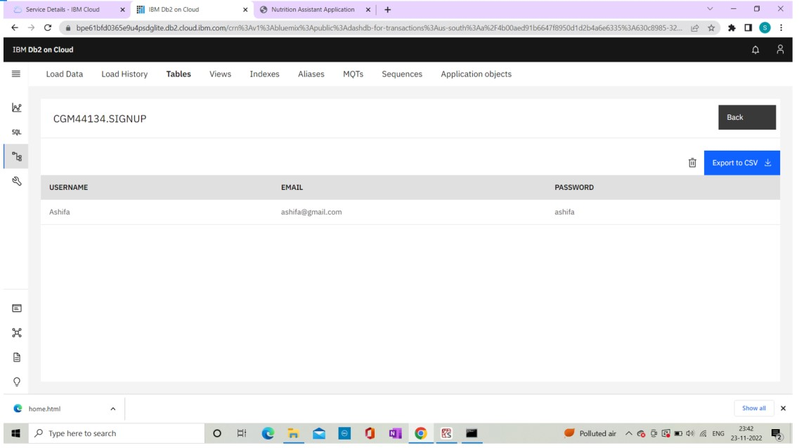

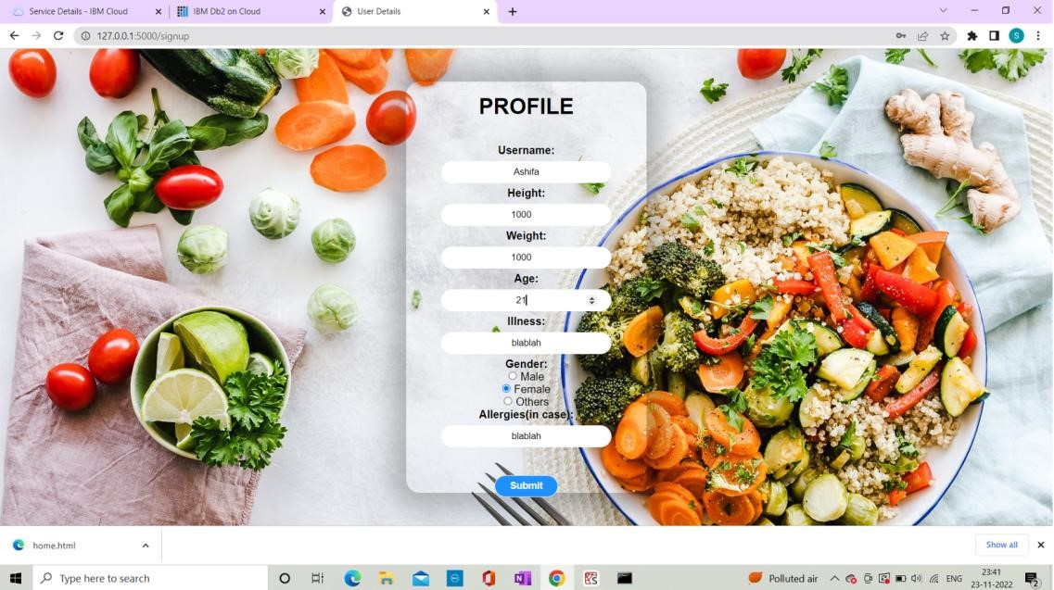

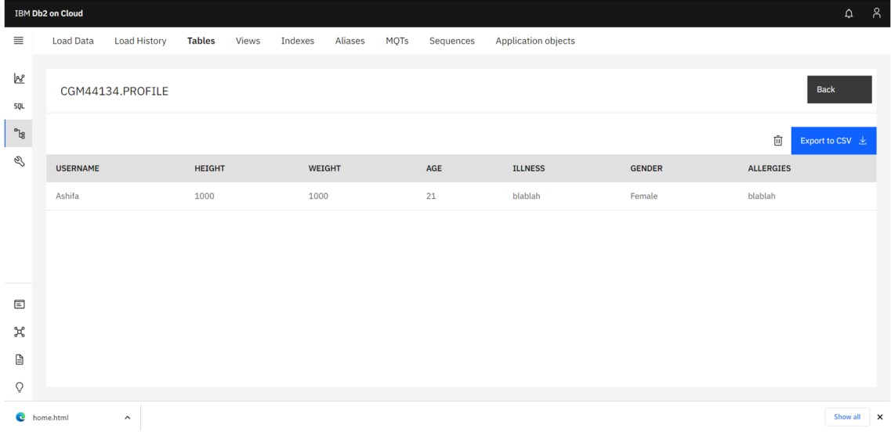

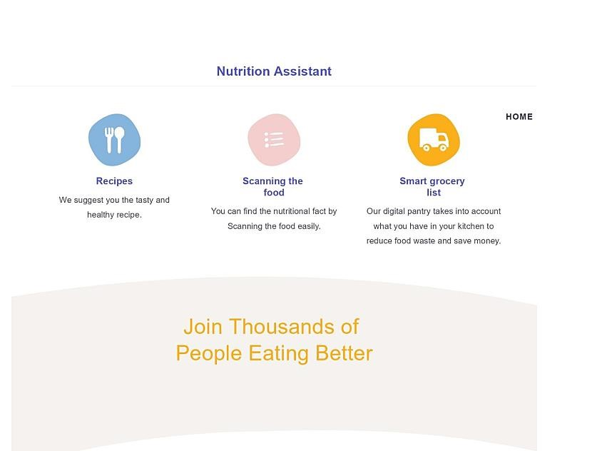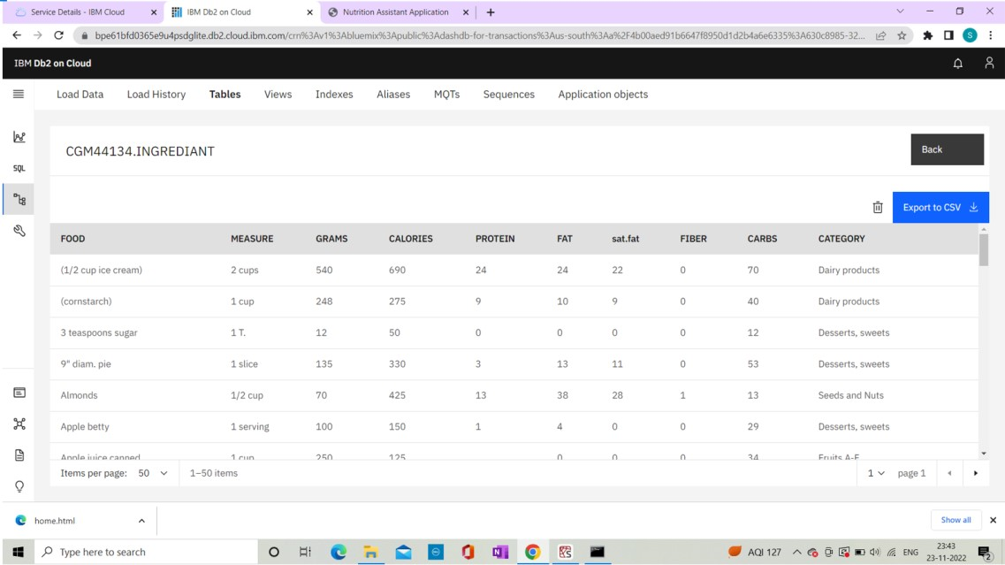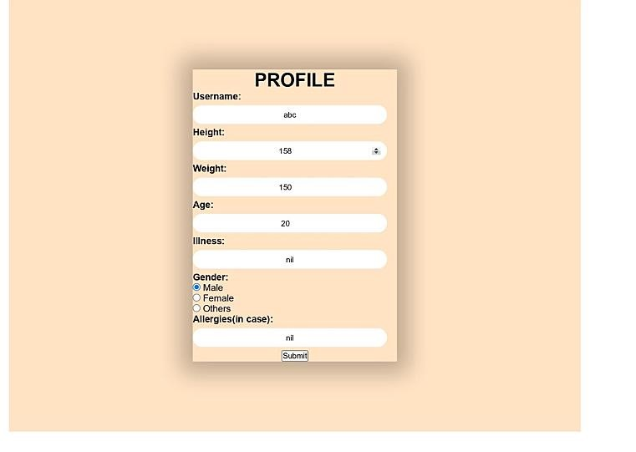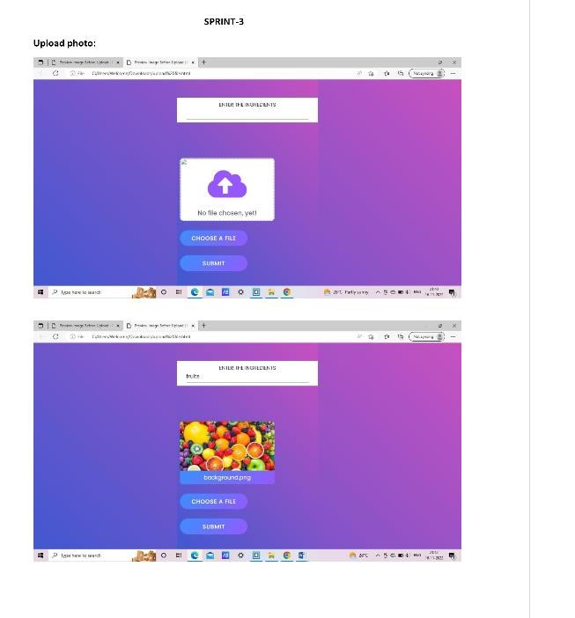

## RESULT

This web app provides the food details if the food image/ URL/ Name is entered. It provides the nutrients involvedin it and also the nutrient value.

*fig : web page to select the serviceimage URL/ food image /food name.*

*fig : Showing the output of the food entered*

Our anotherservice provides the input of aggregate valuesof the nutrient consumed, as per the user requirements

## 10 ADVANTAGES AND DISADVANTAGES 10.1Advantage

Our web app uses the food image given by the user then processes that to the nutrient values of the food then displays to the user. The user can enter the food details that he consumes daily based on time and date of consumption. The user can then go to the diary page and view the data entered by him between any particular dates. He can also view the aggregatenutrient details.

This application can be used on the recommendation of the doctor or the hospitals where one can track all the data that the patient consumed to track the nutrientdetails of the patient.

### 10.2 Disadvantages

As the food around the world is very diverse, it is difficult to recognize some of the local foods. Both the APIs are having a very wide range of food images.But its difficult to find all the food images.

In order to overcome the above disadvantages I have given the field where one can directly enter the food name.

We then process the name to the nutrient values.

## 11 CONCLUSION

As there is improvement in people’s standards of living, there is neglectin the proper balanced diet and this is reflective of the risks to people’s health. People need to controltheir daily calorieintake by eatinghealthier foods.

My web app keeps the record of what the user eat and displays the nutrients he consumed which makes the user to find what nutrients he consumed in what amounts.

## 12 FUTURE SCOPE

As people are in this fast and busy world, it becomes important to track the food details. I have planed to add a feature where the user can set the goal of takingthe nutrients per day / week. then our app tells whetherhe has reached

the goal.

I will also include the service where the user can update his weight and height based on which our app gives the Nutrients data that one needs to consume.

I have also planned to link the daily trackers in the mobiles like Google fit, from where we can get the calories lost and our web app give the data of nutrientsto be consumed.

### APPLICATIONS

This application has the following applications.

1. The uploaded food image is processedand then its the nutrientvalue is displayed.
2. The URL/The food name can also be given as food input.
3. The user can track the daily intake of food
4. User can track the nutrientvalues of the food that He consume.
5. User can store the data in his table in the database.
6. He can access the data whenever he wishes.
7. Users can watch their aggregate nutrientsconsumed and also received the mail of the aggregatereport.
8. This application can be recommended by the doctor/hospitals who wishesto track the food/nutrient consumption of the patient.

## 13.APPENDIX

9. I have used IBM Watson Visual recognition v3 API for Food Model for food recognition. Where it take the food image/URL as input and give the food name as output.

USDA API uses the food name given and then processes it to the nutrient list.

*.*